Georgia Tech Individual Development Plan (IDP) Self-Assessment Form
The aim of this form is to help you think through your long-term career and degree completion goals. Complete each section below (insofar as it is relevant to you), then share it with your advisor(s) for discussion and development. Ideally, you will use this to collaboratively create a document that clearly identifies both your current and long term professional goals, with advice and input from your advisor.
Drawing on the Core Competencies identified by the National Postdoc Association, this form is split into the following four sections:
- Career Exploration and Development
- Degree Completion (graduate students only)
- Knowledge Development
- Professional Skillsets
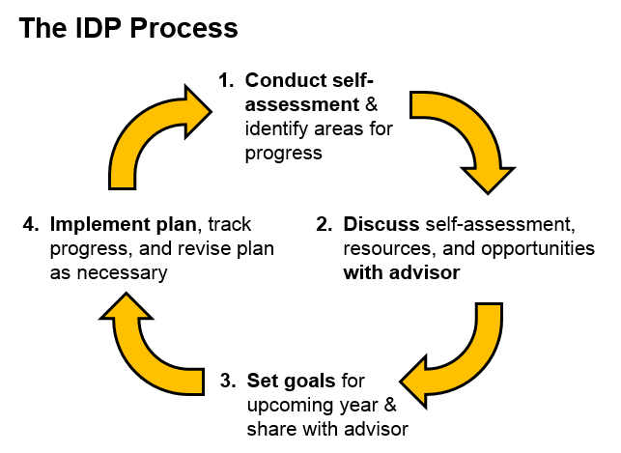
You may end up focusing most of your attention on only a few areas at a time, but it is good practice to reflect on each area in order to help you (and your advisor) identify the best goals and activities for you over the coming months and years.
Use this document as one part of an ongoing plan for your professional development: we recommend that you revisit it at least once a year, to revise and adjust your goals and future plans. We recommend that you retain old versions of this document in order to chart your progress, but use the most recent version as a starting place for creating your plan each year. In addition, it is helpful to use this document as a tool for progress checks throughout the year (e.g. mid-semester check-in, and end-of-semester review).
For more IDP-related resources, please visit http://www.ctl.gatech.edu/resources/best-practices/IDPs.
Career Exploration & Development
Examples | exploring career options, developing skills specific to career of interest, meeting with professionals who already do the job you would like to do, obtaining a certification, developing teaching skills, etc.
Career(s) of interest
Areas of well-established knowledge & understanding
Skills/knowledge to acquire or improve upon
Specific goals for the next year
Ways your advisor & others can help you accomplish these goals
Degree Completion (graduate students only)
Examples | courses, exams, reviews, specific steps toward dissertation completion, etc.
Completed degree requirements
Remaining degree requirements
Specific goals for the next year
Ways your advisor & others can help you accomplish these goals
 |  | Discipline-Specific Conceptual Knowledge | Research & Publication Ethics
Examples |  | detailed knowledge of specific research area, existing work on a specific research question, research advances within the discipline, broad based and cross-disciplinary knowledge acquisition, etc. | compliance with regulations, policies, and guidelines related to: authorship, ethical conduct of research, proper writing practices, conflicts of interest, data ownership and sharing, working with human/animal subjects, etc.
Areas of well-established knowledge & understanding
Skills/knowledge to acquire or improve upon
Specific goals for the next year
Ways your advisor & others can help you accomplish these goals
 |  | Research Skills | Communication Skills
Examples |  | research techniques, experimental design, identifying appropriate research questions, data collection, management, & analysis, developing a literature review, etc. | presenting your work to colleagues and to the public, writing articles, grant proposals, and job application materials, etc.
Strengths & main accomplishments over the last year
Skills/knowledge to acquire or improve upon
Specific goals for the next year
Ways your advisor & others can help you accomplish these goals
 |  | Leadership & Management Skills | Professionalism
Examples |  | contributing new ideas, mentoring & training others, providing feedback to students and peers, project management, running meetings, helping others identify their goals, developing long-term strategic vision, etc. | collegiality, respecting and enhancing the intellectual contributions of others, punctuality, participating in partnerships with external organizations and funding/review panels, networking, etc.
Strengths & main accomplishments over the last year
Skills/knowledge to acquire or improve upon
Specific goals for the next year
Ways your advisor & others can help you accomplish these goals

