Opening Activity
Use the space below to reflect on the following question:
What would you do to make your courses even more inclusive if you had all the support you needed?

PREP and EDIT Framework from –
Fitzpatrick, Fox, & Weinstein (2023) The AI Classroom: The Ultimate Guide to Artiﬁcial Intelligence in Education
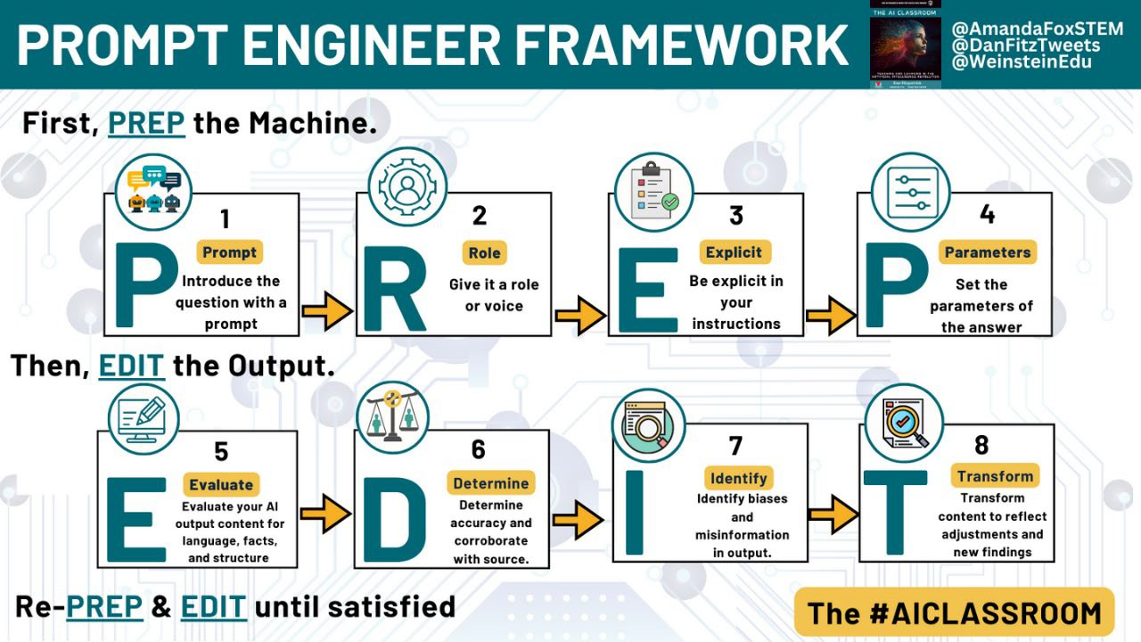

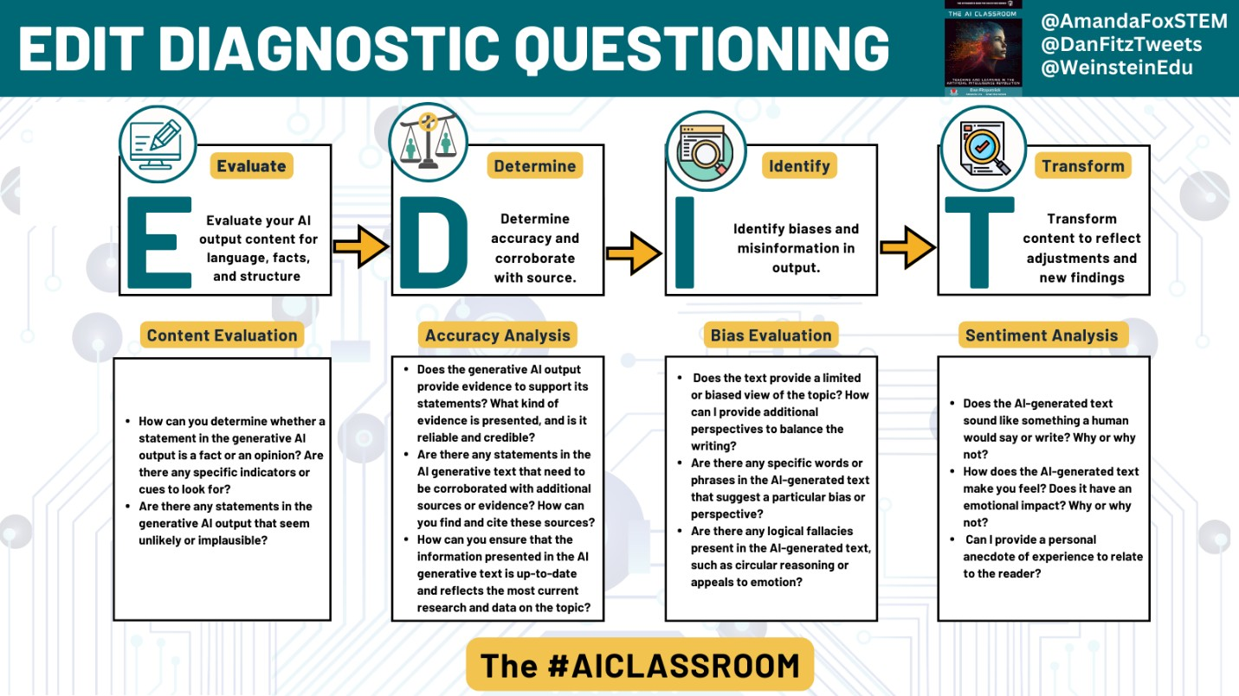
Highly structured courses that engage students in continuous opportunities for practice with feedback create a more inclusive learning environment than courses with low structure (Hogan and Sathy 2022). Practice using the Brainstorming Tool on Teaching Tools to generate ideas to add structure to one of your courses. (This tool requires a free account. A CTL representative can help you if you don’t have an account of your own yet.
Activity 1
Use the space below to make notes about any ideas you think are worth pursuing and reflect on this approach/tool. For example, consider:
- How might you use this tool to add structure to your courses?
- How aligned with your expectations was this tool's output?
- What concerns do you have about this tool?

The Universal Design for Learning (UDL) Guidelines are a set of evidence-based recommendations designed to help educators provide accessible and inclusive learning experiences for all students (CAST 2018). Rooted in cognitive neuroscience, UDL recognizes that every learner is unique and that a one-size-fits-all approach to education often misses the mark. The guidelines are organized around three main principles: (1) Engagement, ensuring students remain motivated and invested in their learning; (2) Representation, presenting information in multiple formats to cater to varied learning preferences; and (3) Action & Expression, offering students multiple methods to demonstrate their knowledge and skills. By addressing these three key aspects, UDL aims to eliminate barriers to learning without sacrificing rigor, enabling all students, regardless of their backgrounds or abilities, to become successful learning in their academic pursuits.
Activity 2
Choose one of the three areas of UDL you want to focus on and use the space below to reflect on ideas on how you might leverage AI to support your efforts in this area. For example, think about:
- What kind of AI tool might I need?
- Will this be a tool I use or is this a tool I would suggest students use?
- If you choose to focus on Representation, try out one of the summary tools such as skipit.ai or scisummary.com and reflect on how well this tool worked for you.

In culturally responsive teaching, students are motivated to pursue success because they are engaged in learning that matters to them; develop/maintain their sense of cultural integrity and engage in critical consciousness by challenging the status quo of the current order (Ladson-Billings 1995). There are many ways to engage in culturally responsive teaching, such as inviting students to use the languages they are most comfortable speaking as part of their learning experience. AI can help enhance these practices. For example, you might use DeepL Language Translation to translate your course policies or assignment prompts into the languages your students speak.
Other times you may want to tailor an assignment or class activity to reflect the communities and issues that are important to your students. In this case, a general AI tool, like ChatGPT, may be best. You can use frameworks like PREP and EDIT, to craft prompts that help you generate personalized learning activities.
Activity 3
Use the space below to reflect on ideas to make your courses more culturally responsive. How might AI support your efforts?

Closing Activity
Recall your earlier reflection on your aspirations to make your courses more inclusive if you had the support to do so. Explore this idea with one or more AI tools. How might AI help you enhance inclusive teaching in your course? Use the space below to make notes about your ideas.

Share your ideas on our workshop Padlet. Leave your name so you can connect to others with similar ideas.

Please take a minute to complete the Workshop Survey. We value and use your feedback to enhance our future programing.

