**What are the U.N. Sustainable Development Goals?**

# The United Nations (U.N.) Sustainable Development Goals (SDGs) are a set of 17 broad and interconnected goals that address the global challenges humanity faces. They were developed as part of the 2030 Agenda for Sustainable Development, adopted by all U.N. member states in 2015. The SDGs are comprehensive and visionary, including ending poverty and hunger, reducing inequality, and strengthening the health of human communities and ecosystems globally.

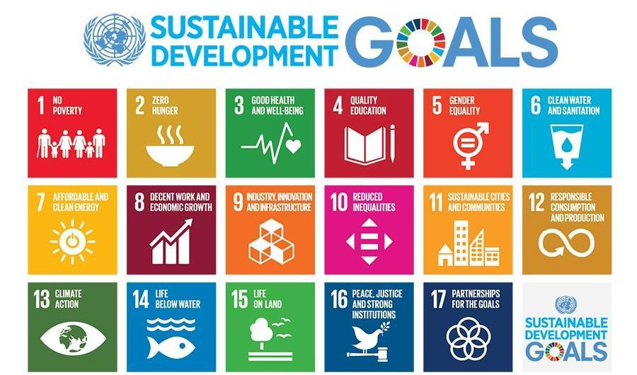

The SDGs build on several earlier global frameworks for sustainable development including Agenda 21, adopted in 1992 at the Earth Summit in Rio de Janeiro, Brazil, and the Millennium Development Goals (MDGs) that served as a global guide for reducing extreme poverty from 200 to 2015. Read a detailed history of the SDGs [here](https://sdgs.un.org/goals).

Review detailed information about each of the Goals, including targets, and find related initiatives and resources [here.](https://www.un.org/sustainabledevelopment/sustainable-development-goals/)This page also includes a roughly 30-minute video that introduces the SDGs in the context of the COVID-19 pandemic and growing collective action in response.

**Incorporating Education for Sustainable Development into College Teaching**

**What is Education for Sustainable Development (ESD)?**

The terms associated with this field of study and practice have changed over time and include Environmental Education, Ecological Literacy, Education for Sustainability, Education for Sustainable Development (ESD), and, most recently, Education for the Sustainable Development Goals (ESDG) (Rest, 2002). The United Nations Educational, Scientific and Cultural Organization’s (UNESCO) description of ESD includes the following:

*Education for Sustainable Development (ESD) empowers learners with knowledge, skills, values and attitudes to take informed decisions and make responsible actions for environmental integrity, economic viability and a just society… [ESD] enhances the cognitive, social and emotional and behavioral dimensions of learning. It is holistic and transformational, and encompasses learning content and outcomes, pedagogy and the learning environment itself* (UNESCO, 2022).

ESD and ESDG frameworks typically categorize different kinds of knowledge and skills considered to be important for preparation that equips students to contribute to a more just and sustainable future. Sustainability skills are sometimes framed as “competencies” considered to be important for understanding and engaging in complex societal challenges. These broad sets of knowledge, skills, and competencies can help instructors frame course, unit, and lesson learning outcomes or objectives.

As suggested by UNESCO’s description, above, one of the key elements of ESD is its distinction as Education *for* Sustainable Development, in contrast to Education *about* Sustainable Development. ESD is intended to be transformative and to motivate and empower students to act as change-makers in their communities—putting their knowledge and skills developed through ESD to work in the world.

Another key element of ESD is *transdisciplinarity*. The importance of transdisciplinarity in higher education to tackling complex global problems is widely accepted but there is no single, widely accepted definition for transdisciplinary learning. In their review of transdisciplinarity and related terms in sustainability research, Stock and Burton (2011:1102) offer this description:

*“[Transdisciplinarity] maintains a clear emphasis on developing a wholistic approach to problem solving involving stakeholders and scientists in a joint project… extending the research beyond simply problem solving towards synthesizing new bodies of knowledge with which to address systems problems.”*

Applying this description to sustainability learning suggests that transdisciplinary teaching is wholistic, encompasses knowledge generated not just across disciplines but outside academics, and enables students to synthesize knowledge in new ways to solve complex problems.

**Further Exploration: Sustainability Competencies**

If you are interested in exploring “key competencies” for sustainable development in greater depth, consider reviewing UNESCO’s (2018) [Issues and Trends in Education for Sustainable Development](https://www.sustainabilityexchange.ac.uk/files/unesco_-_issues_and_trends_in_education_for_sustainable_development.pdf). The authors of this resource identified the following competencies as common to frameworks:

|  |  |  |  |
| --- | --- | --- | --- |
| Systems thinking | Anticipatory | Normative | Strategic |
| Collaboration | Critical thinking | Self-awareness | Problem-solving |

In addition to these competencies, and consistent with the socio-emotional category included above, ESD recognizes that values, motivation, and opportunities also are essential for transforming capabilities into actions ([Rieckmann, 2018](https://unesdoc.unesco.org/ark:/48223/pf0000261954?1=null&queryId=29c0e728-c85b-40dd-9426-b3530d64abab)).

**Further Exploration: Pedagogies for ESD**

Consistent with the holistic, problem-solving, and transformative goals associated with ESD, pedagogies recommended by ESD scholars and practitioners tend to emphasize real-world learning approaches. More specifically, Evans (2019) found the following pedagogies most often recommended in ESD literature: problem-based learning in organizations/communities; problem-based learning in the classroom; and integrative learning that transcends disciplines. The recent National Academies of Science report [*Strengthening Sustainability Programs*](https://drive.google.com/drive/folders/10HlbCyH67_ukLw_a106-PFVjmHnkOqWh) (2020) also points to the importance of experiential learning settings and problem-based and solution-based content to sustainability education. These common ESD pedagogies align well with many “[High Impact Practices](https://www.aacu.org/trending-topics/high-impact),” especially service-learning/community-based learning, diversity/global learning, collaborative assignments and projects, and capstone courses and projects.

**Further Exploration: Empowering Change-Makers**

Incorporating opportunities for students to learn about and explore their role in social change processes is an important component of ESD. This aspect of ESD also may be daunting for instructors outside fields that typically incorporate social change, such as history, sociology, and policy courses. Community-engaged learning in partnership with organizations working for change can be an effective and engaging way to incorporate this element of ESD. In addition, Minnesota and Iowa Campus Compact have developed a tool that can help instructors introduce students to social change. Explore the [Social Change Wheel Toolkit 2.0](https://mncampuscompact.org/resource-posts/social-change-wheel-2-0-toolkit/) for helpful resources and ideas.

**References and additional reading:**

American Association of Colleges and Universities (AAC&U), 2022. High-Impact Practices. <https://www.aacu.org/trending-topics/high-impact>.

Evans, T. L. (2019). Competencies and pedagogies for sustainability education: A roadmap for sustainability studies program development in colleges and universities. *Sustainability*, 11(19), 5526.

Holm, T., Sammalisto, K., Caeiro, S., Rieckmann, M., Dlouhá, J., Wright, T., ... & Lozano, R. (2016). Developing sustainability into a golden thread throughout all levels of education. *Journal of Cleaner Production*, *117*(20), 1.

National Academies of Sciences, Engineering, and Medicine. (2020). Strengthening sustainability programs and curricula at the undergraduate and graduate levels. Washington, DC: [The National Academies Press](https://drive.google.com/drive/folders/10HlbCyH67_ukLw_a106-PFVjmHnkOqWh).

Rest, A. (2002). From Environmental Education to Education for Sustainable Development. *Environmental Policy & L.*, *32*, 79.

Rieckmann, M. (2017). *Education for sustainable development goals: Learning objectives*. [UNESCO Publishing](https://www.unesco.de/sites/default/files/2018-08/unesco_education_for_sustainable_development_goals.pdf).

Rieckmann, M. (2018). Learning to transform the world: Key competencies in Education for Sustainable Development. *Issues and trends in education for sustainable development*, *39*, 39-59.

Stock, P. & Burton, R.J.F. (2011) Defining terms for integrated (multi-inter-trans-disciplinary) sustainability research. Sustainability, 3(8), 1090. <https://doi.org/10.3390/su3081090>

UNESCO, 2022. What is Education for Sustainable Development? <https://en.unesco.org/themes/education-sustainable-development/what-is-esd>.

**Planning SDG(s) Course Integration: Key Considerations**



1. After browsing through the SDG descriptions, targets, and suggested learning objectives in [Sustainable Foundations: A Guide for Teaching the Sustainable Development Goals](http://mcic.ca/uploads/public/files-sf/SF-Full-FINAL-WEB-ISBN-2021-EN.pdf) and/or [Education for Sustainable Development Goals: Learning Objectives](https://unesdoc.unesco.org/ark:/48223/pf0000247444), which SDGs seem like the most obvious candidates for your course?

1. Consider some of the key elements of Education for Sustainable Development and Sustainability Competencies. Use the following questions to prioritize the elements that best align with your course.

What opportunities do the SDGs provide to incorporate interdisciplinary or transdisciplinary learning in your course?

What are some ways that you might use the SDGs to empower students as change agents, now and in their future careers (contribute to societal transformation)?

What kinds of case studies aligned with your course might help students understand complex global problems and also help them develop the skills to evaluate and imagine potential solutions?

1. Which of the SDGs have associated learning objectives that overlap with the learning objectives for your course? List them below.
2. For some courses, such as mathematics, data analysis, and econometrics, you may be able to incorporate just about any of the SDGs. If that is the case, consider the pros and cons of allowing students, or student teams, to explore data relating to an SDG of their choosing, versus selecting a single SDG as the focus of your investigations throughout the course.

Pros and cons of student choice:

Pros and cons of single SDG focus:

1. Of the SDGs listed in #1 and #3, above, consider how they align with your interests, expertise, and available resources.

I am most interested in learning more about these SDGs:

I feel I have the most resources and expertise in relation to these SDGs:

1. Given all these considerations, I think I will incorporate the following SDG(s) in my course:
2. In addition to concepts and competencies associated with *specific SDGs and their targets*, consider what you expect students to be able to articulate about *the SDGs as a global framework*. For example, do you want students to be able to explain the purpose of the SDGs, or identify a critique or limitation? Record your ideas below, or use these organizers:

I also want to be sure that students understand _________________ about the SDGs as a global framework for social change.

I want my students to be able to explain/evaluate/analyze/design/apply/imagine/(other_________) _______________________________ in relation to the SDGs.