**Worksheet: Designing and Integrating ESD/SDG Learning Objectives for Your Course**

Before you begin to develop Student Learning Objectives (SLOs) to incorporate SDGs into your course, consider what kinds of SLOs you typically craft and how they relate tothese three categories of learning objectives suggested by UNESCO:

1. Cognitive learning objectives
2. Socio-emotional learning objectives
3. Behavioral learning objectives

See page 11 of UNESCO’s resource [Education for Sustainable Development: Learning Objectives](https://unesdoc.unesco.org/ark:/48223/pf0000247444) for a description and examples of each kind of SLO. Incorporating all three kinds of SLOs can help you remember to consider relevant knowledge, skills, dispositions, and opportunities for action-taking as you design lessons, modules, and student projects.

**EXAMPLES:** The following examples show how cognitive, socio-emotional, and behavioral SLOs could be developed for SDG 1: No Poverty. These examples are adapted from ones provided in UNESCO’s (2017) [Education for Sustainable Development Goals: Learning Objectives:](https://www.unesco.de/sites/default/files/2018-08/unesco_education_for_sustainable_development_goals.pdf)

1. **Cognitive learning objectives**: *Students provide examples of effective poverty reduction policies and distinguish between deficit-based and asset-based approaches to addressing poverty.*
2. **Socio-emotional learning objectives**: *Students articulate their own role in relation to structural factors that contribute to poverty.*
3. **Behavioral learning objectives**: *Students identify and engage in public and private decision-making processes that influence poverty generation and alleviation.*

**Step 1:** Revisit your existing course learning outcomes and identify relevant SDGs

Review the existing course learning outcomes and consider them in relation to [the SDGs](https://sdgs.un.org/goals). Which SDG or SDGs are most relevant to your course? Will you incorporate one or multiple? Throughout the course or in a single lesson or unit?

List your current course students learning objectives (SLOs) here:

List your current unit/module SLOs here:

List your current lesson SLOs here:

**Step 2**: Identify “big ideas” or key questions associated with the SDG(s) you have chosen and develop an associated learning objective(s) that is student-centered, action-oriented, measurable, and precise (see our *SDG Course Design Handout* for detailed guidance on writing effective SLOs). Decide whether to integrate the SDG SLOs with existing course or unit SLOs or add them as additional SLOs.

These resources provide suggested learning objectives for each SDG:

[Sustainable Foundations: A Guide for Teaching the Sustainable Development Goals](http://mcic.ca/uploads/public/files-sf/SF-Full-FINAL-WEB-ISBN-2021-EN.pdf)

[Education for Sustainable Development Goals: Learning Objectives](https://unesdoc.unesco.org/ark:/48223/pf0000247444)

*Hint:* Some of the learning objectives in these resources align with widely accepted criteria for effective learning objectives—and others are formatted differently. As you review these resources, consider them as helpful starting points and evaluate them critically, as you would your own course design work, and re-shape if needed.

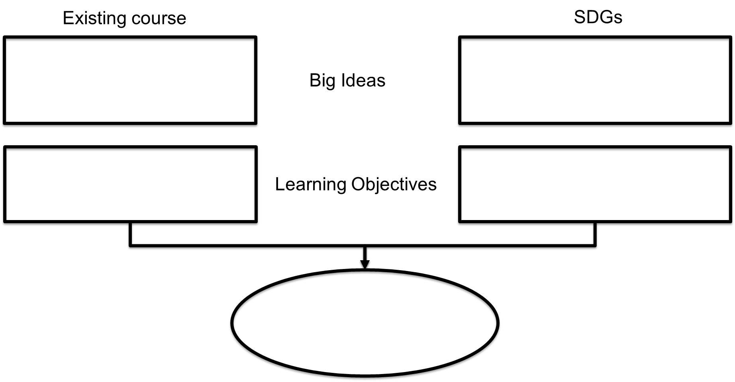

**Step 3:** Evaluate revised course learning objectives in relation to different kinds of learning objectives.

Which of the categories below do your SDG learning objectives align with most closely? Consider whether adding another dimension would strengthen the learning outcomes.

* Cognitive learning objectives
* Socio-emotional learning objectives
* Behavioral learning objectives

**Step 4:** List your revised set of course student learning objectives (SLOs) here:

List your revised unit/module SLOs here:

List your revised lesson SLOs here: